**Frankfurt University of Applied Sciences**



**Master Information Technology**

**Course: Agile Development in Cloud Computing Environments - SoSe 22 – SS 2022**

***Prof. Patrick Wacht***

**Topic: Travel Application Website (AWS Platform)**

Submitted by:

**Gaurav Honnavara Manjunath** (1384178)

**Manoj Kuridoddi Marigowda**(1348114)

Date of submission: **June 29, 2022**

Table of Contents

1. Introduction 3

2. Kanban 3

2.1 Principles Of Kanban 3

2.2 Core Properties of Kanban 3

3. Scrum 4

4. User stories and Backlog 4

5. Implementation 4

5.1 Project Estimation 5

**5.1.1** **Sprint 1 (Phase I)** 5

**5.1.2** **Sprint 2 (Phase II)** 6

**5.1.3** **Sprint 3 (Phase III)** 7

**5.1.4** **Sprint 4 (Phase IV)** 9

5.2 Programming Language & Tools 10

5.3 Architecture 11

Class diagram of Travel Application as show below. 11

11

6. Process of incorporating Agile principles to the Travel Web App development & Opinion on these principles: 11

7. Conclusion 11

# **Introduction**

Agile software development has had a significant influence on how software development is conducted. It allows software developers to plan and coordinate their work, communicate with customers and external stakeholders, and organise software development in small, medium-sized and large companies from the telecom and healthcare sectors to games and interactive media.

Some of the Agile approaches are

* Collaboration between the development team and business stakeholders
* Frequent delivery of business value
* Self-organizing teams
* Innovative ways to create, test and deploy code

# **Kanban**

The Kanban method approaches incremental, evolutionary processes and systems change for organizations.

Kanban can be described as

* A way to organize the chaos surrounding so many delivery teams is by clarifying the need for prioritization and focus.
* A way to uncover workflow and process problems so you may solve them to deliver more consistently to your client/customer/etc.

## Principles Of Kanban

* Start with what you do now
* Agree to pursue incremental, evolutionary change
* Respect the current process, roles, responsibilities & titles
* Encourage acts of leadership at all levels

## Core Properties of Kanban

* Visualize the workflow
* Limit WIP
* Manage flow
* Make Process Policies Explicit
* Improve Collaboratively (using models & the scientific method)

# **Scrum**

Scrum is a framework for developing and sustaining complex products.

Scrum requires a Scrum Master to foster an environment where:

* + A Product Owner orders the work for a complex problem into a Product Backlog.
  + The Scrum Team turns a selection of the work into an Increment of value during a Sprint.
  + The Scrum Team and its stakeholders inspect the results and adjust for the next Sprint.
  + Repeat

# **User stories and Backlog**

With customer Interaction, the team divides the work into small pieces called 'user stories'. Each story should be independent and is expected to produce a contribution of value to the overall product.

A backlog is a list of features or technical tasks the team maintains. The backlog is the primary entry point for knowledge about requirements and the single authoritative source defining the work to be done. The backlog is expected to change throughout the project's duration as the team gains knowledge.

# **Implementation**

The project aims to develop and implement travel applications and hosting in Cloud (Amazon Web Services (AWS)). The project required the team to use agile methodology for development, including cross-platform integration such as Train Service, Flight Service, Taxi Service, Payment services and a Smart Robo adviser to advise the user using REST APIs. The Application also includes a user interface where our customers can register with the Application by signing up and logging in with stored data. The Application allows users to create a new request enabling the users to consume the RESTful services. The Project timeline was Planned for 4 Sprints, with each sprint interval of 2 weeks. Induvial Sprints involved tasks in Understanding Customer requirements, Development, Integrate, Testing and Delivering the product after the end of the project timeline.

Understanding the principles of Agile Methodology, the team planned different sprints to deliver the product. The project planning was done using Kanban Board.

## **Project Estimation**

The Team initially worked on Understanding Customer Requirement, Project Requirement and follow the timeline to deliver the product within the speculated deadline.

The timeline was planned for 4 Sprints with each sprint interval of 2 weeks

With 2 resources in the team.

Project Estimation (Kanban Board Link): <http://54.93.249.238/b/yzqpdYrwdaHfPRkPM/travel-app>

### **Sprint 1 (Phase I)**

|  |  |
| --- | --- |
| **Planning Phase (**4.5.2022 - 18.5.2022) | |
| **Product Backlog** | Basic Understanding of AWS Platform |
| Explore AWS Platform |
| Explore different Travel Application (Internet) |
| Plan Input Parameters Required for our Travel Application |
| Plan & Initial Setup of AWS Platform (EC2 Instance) for Hosting our Travel Application |
| Explore different servers (Apache, XAMAPP) & SQL database Required for our Website |
| Initial Outlay of Travel Application using (HTML & CSS, or C# .Net FrameWork)  Discuss with Teams to understand product requirement & Understand their Specification |
| **Sprint Backlog** | Kickstart -> Create AWS Account (Student Account) |
| Create an Instance (EC2 Instance) |
| Use Azure Portal to Create a basic Web Application (Since it is Familiar Platform) |
| Host Web Application Created using Visual Studio (C# or .NET Framework) |
| Implement input Parameters required for Travel Web Application |
| Database Setup for storing User Parameters |
| **Sprint Review** | Created AWS Account and understand AWS Platform |
| Able to capture Input Parameters Required for Our Travel Application |
| Created EC2 instance in AWS and host a demo website using EC2 Instance |
| Create a web Application using C# & .NET Framework and host using Azure |
| Database Setup for Storing Input Parameters |
| Discussed with Other Teams to Understand Product Requirement & Specification |
| **Retrospective** | Team was able to develop a basic web application using C# .NET Framework, but could foresee future risks and Incompatibility Issues if Product is developed using C# & .NET Framework (Discussed with Professor And Teammates and Come up with backup Plans) |
| Team was able to host a basic web application in AWS Platform using static, eventually  the team worked around to make the web application host dynamically |

*Table 1. Sprint 1 details – Kanban Board*

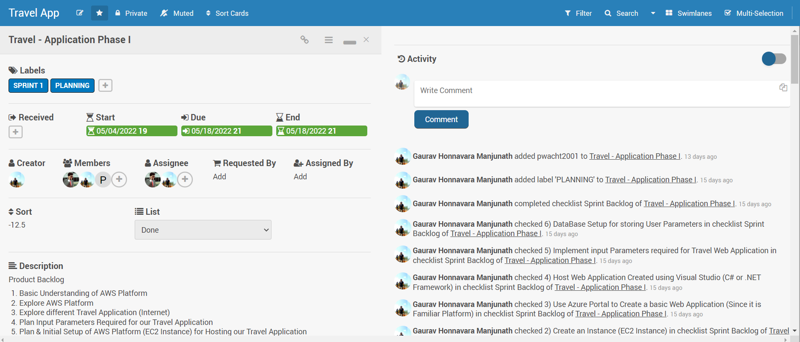

*Fig 1. Sprint 1 details – Kanban Board*

### **Sprint 2 (Phase II)**

|  |  |
| --- | --- |
| **Development Phase (**18**.**5.2022 - 1.6.2022) | |
| **Product Backlog** | Create Initial website using HTML and CSS - Travel Application |
| Setup php server for further development with Travel Application |
| Host Initial Website developed in AWS Platform |
| Develop Initial User Interface (Registration and Login) |
| Store User Credentials and Data in MySQL |
| Discussion with Teams to be in line with product Integration & Specification Sprint Backlog |
| **Sprint Backlog** | Develop Initial Website using HTML& CSS using VS Code |
| PHP Server Creation using Apache Server |
| Hosting Initial Website in AWS Platform (Initial Website interface) |
| Develop Registration Form, Login Page & UserInterface |
| Test registration form, Login Page & User Interface |
| Store User Credential and User Data in Database |
| Discuss with any one of the cross connected Teams and basic integrate their platform |
| **Sprint Review** | Developed Initial Website using HTML & CSS |
| Host Initial website in AWS Platform |
| Developed Registration form, Login Page & User Interface |
| Test Registration form, Login Page & User Interface |
| Stored User Credential & User Data in Database |
| **Retrospective** | Delay in Interaction with Team for understanding Basic integration and Parameter |
| Delay in start of Sprint 2 Development as Team was working around with a Plan which  foresaw future risk and compatibility Issue |
| Moved Few Tasks related to Server and Integration Testing to Sprint 3 to avoid delay in Timeline |

*Table 2. Sprint 2 details – Kanban Board*

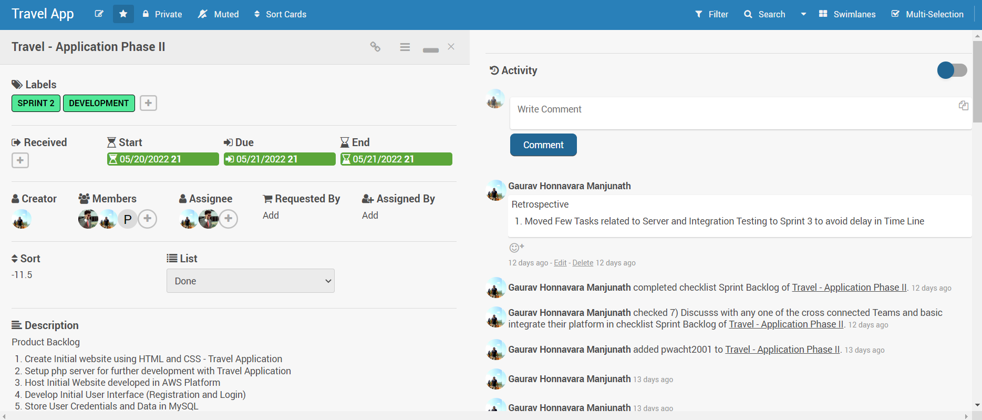

*Fig 2. Sprint 2 details – Kanban Board*

### **Sprint 3 (Phase III)**

|  |  |
| --- | --- |
| **Integration & Testing Phase (**2**.** 6.2022 - 15.6.2022) | |
| **Product Backlog** | Discuss with Railway Service & Flight Service Team |
| Integration of APIs with Travel Application |
| Testing of APIs |
| Resolve issues Bugs after Integration |
| Hosting Website in AWS |
| **Sprint Backlog** | Discussion with Flight Service & Railway Service Team |
| Understand RESTful APIs Developed by Flight Service Team |
| Understand RESTful APIs Developed by Railway Service Team |
| Integrate RESTful API Developed by Flight Service Team |
| Integrate RESTful APIs Developed by Railway Service Team |
| Test Integrated API - Flight Service |
| Test Integrated API - Railway Service |
| **Sprint Review** | Discussion with Flight Service & Railway Service Team |
| Understand RESTful APIs Developed by Flight Service Team |
| Understand RESTful APIs Developed by Railway Service Team |
| Integration RESTful APIs Developed by Flight Service Team |
| Testing RESTful APIs Developed by Flight Service Team |
| Integration of RESTful APIs Developed by Railway Service Team |
| **Retrospective** | Opened Bug Sprint to take actions on Missing Items |

*Table 3. Sprint 3 details – Kanban Board*

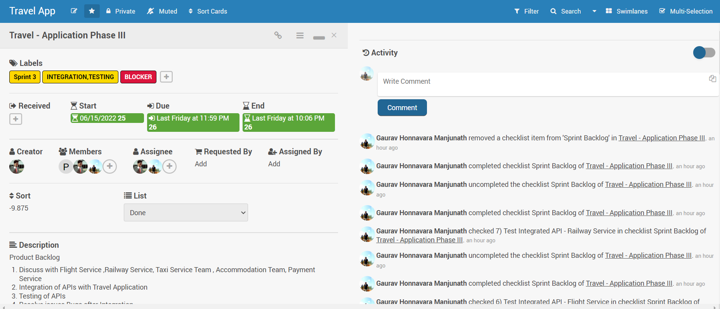

*Fig 3. Sprint 3 details – Kanban Board*

|  |  |
| --- | --- |
| **Mid Phase Development (**18**.** 6.2022 - 22.6.2022) | |
| **Product Backlog** | Front End Development for Flight Service, Railway Service, Taxi Service , Accommodation Service |
| Integrate Missing RESTful APIs From Flight Service, Train Service. |
| Resolve Persistent/Old Bugs. |
| **Sprint Backlog** | Front End Development for Flight Service |
| Front End Development for Railway Service |
| Resolve Bugs |
| **Sprint Review** | Developed Front End for Train Services |
| Developed Front End for Flight Services |
| Tested Backend Server(Apache Server & myadminPHP to Store User Credentials) |
| Template Creation for future Development for Taxi & Accommodation Services and Integrating User Data. |
| Test REST API shared by Train & Flight Services |
| **Retrospective** | Delay in Delivering APIs from Cross platform from Team Accommodation Services. |
| Less Time Constraint led to Integration of Functional Aspects of Flight Service, Train Service and User Credentials. |
| APIs from Taxi Service and Payment Service was not Delivered |

*Table 4. Sprint 3(Mid-Phase Sprint) details – Kanban Board*

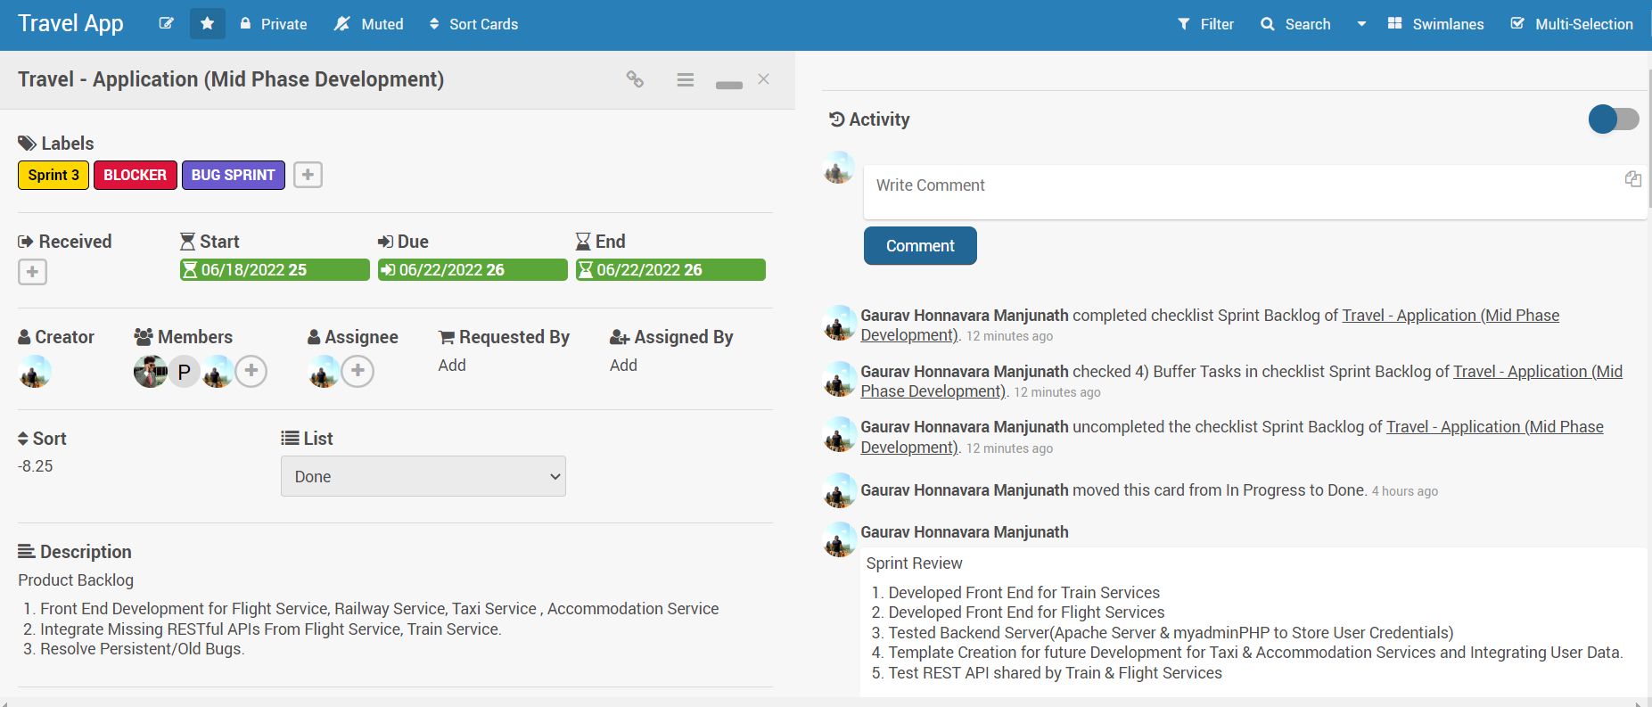

*Fig 4. Sprint 3(Mid-Phase Sprint) details – Kanban Board*

### **Sprint 4 (Phase IV)**

|  |  |
| --- | --- |
| **Alpha Release (**16**.** 6.2022 - 29.6.2022) | |
| **Product Backlog** | Test Travel Application for Alpha Release |
| Test REST APIs - For Bugs and Glitches |
| Documentation |
| Release Source Code, Documentation and GitHub Repository |
| **Sprint Backlog** | Travel Application Testing - Alpha Release |
| REST APIs Testing |
| Backend Server Test |
| Test Application in AWS Platform |
| Alpha Release |
| Documentation |
| **Sprint Review** | Tested Travel Application (Locally, AWS Platform) |
| Tested Backend Server for Bugs and Glitches |
| Delivery of Project Content by following Agile Methodology |
| Alpha Release (Deliver Source Code, Documentation and GitHub Repository) |
| **Retrospective** | Delay in Delivering APIs from Accommodation Team. |
| No APIs were delivered from Taxi Service, Payment Service |
| Tight timeline led to Integration of APIs (Working APIs for Alpha Release) |
| Alpha Release includes Front End Development and Backend Development |
| Under Estimation of Team Resources (Less Number of Resources), Strict Timeline. |

*Table 5. Sprint 4 details – Kanban Board*

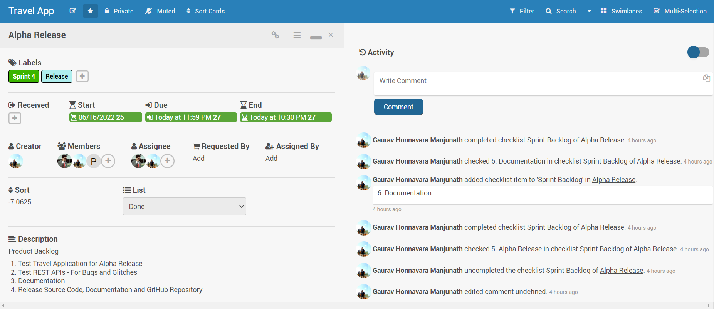

*Fig 5. Sprint 4 details – Kanban Board*

## **P****rogramming Language & Tools**

* **Platform**: Visual Studio Code
* **Language**: HTML, CSS, JS, Bootstrap
* **Cloud**: Amazon Web Service (EC2 Instance & S3 Storage)
* **Backend Server:** Apache24, phpMyAdmin, XAMPP Control Panel
* **Project Estimation** Tool: Kanban
* **Version Control:** GitHub Repository

## **Architecture**

## Class diagram of Travel Application as show below.

## 

Login/Signup

Flight Service

Train Service

Book

Enquire

Booking Details

Login

Search Flights

Signup

Reschedule Flight

Get Flight Booking Status0

Book Flight

Cancel Flight

# **Which agile best practices have been established?**

# **How have you applied the push and pull principle?**

# **How did you measure complexity of tasks?**

# **How did you collaborate with the customer?**

# **What is the opinion of the team regarding agile principles?**

# **Was it necessary to have the roles Product Owner and Scrum Master?**

# **Conclusion**

# **References**